Day 8 Assignment

**Question 1:**

1. **Secure an IIS web server by configuring SSL/TLS encryption using a self-signed or third-party certificate.**

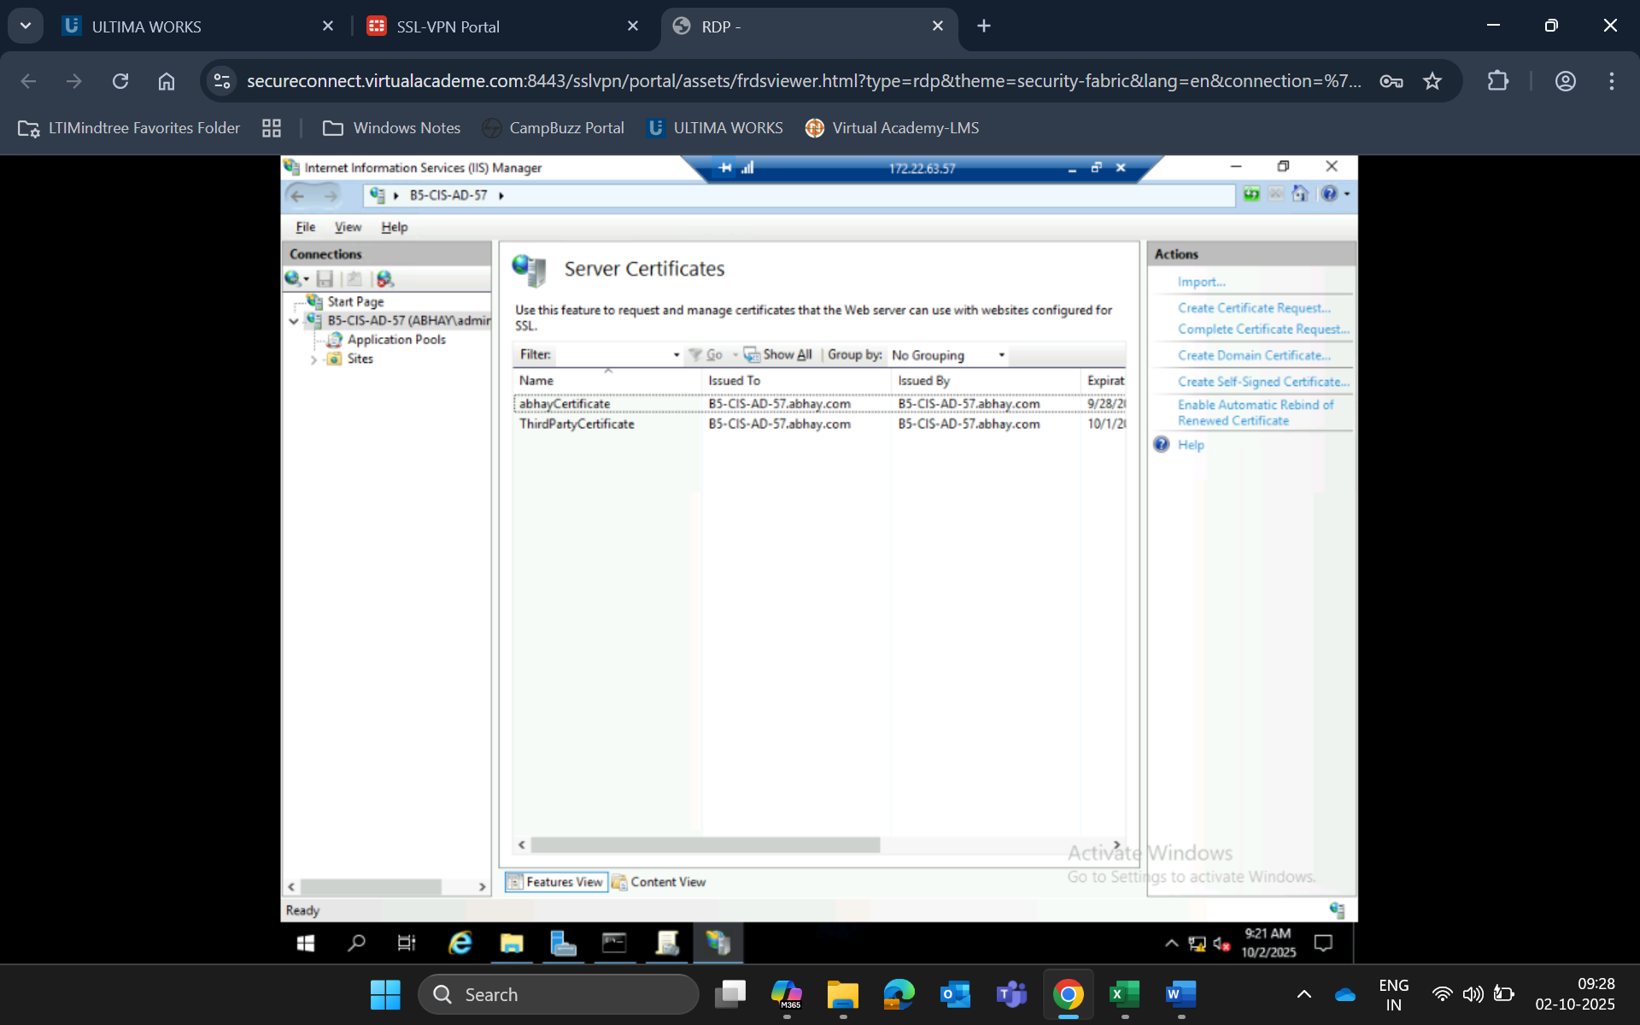

1. **2. Set up multiple websites on a single IIS server using different hostnames, IP addresses, and ports.**

1. Create a script to export and import IIS configurations across multiple servers
2. **Export IIS Configuration (on Source Server)**

PowerShell

powers isn’t fully supported. Syntax highlighting is based on PowerShell.

# Export IIS configuration to a file

$backupPath = "C:\IIS_Backup\iis_config_export.xml"

$appcmd.exe add backup "IISBackup"

appcmd.exe list backup "IISBackup"

# Export full configuration

appcmd.exe export config /config:$backupPath

Write-Host "IIS configuration exported to $backupPath"

1. **✅ Import IIS Configuration (on Target Server)**

PowerShell

# Import IIS configuration from a file

$importPath = "C:\IIS_Backup\iis_config_export.xml"

# Restore configuration

appcmd.exe import config /config:$importPath

Write-Host "IIS configuration imported from $importPath"

1. **✅ Alternative: Using Web Deploy (Recommended for Full Site Migration)**
2. **🔹 Export Site with Web Deploy**

PowerShell

msdeploy.exe -verb:sync -source:apphostconfig="Default Web Site" -dest:package="C:\Backup\DefaultWebSite.zip"

Show more lines

1. **🔹 Import Site on Target Server**

PowerShell

msdeploy.exe -verb:sync -source:package="C:\Backup\DefaultWebSite.zip" -dest:apphostconfig="Default Web Site"

1. **✅ Notes:**

* Ensure **Web Deploy** is installed on both servers.
* Run PowerShell as **Administrator**.
* You can use appcmd list site to view available sites.
* For remote operations, use PowerShell Remoting or WinRM.